**Chapter 1 Summary:**

**WHY INFORMATION SYSTEMS MATTER IN BUSINESS - AND TO YOU**

**As you read this chapter, focus on these key concepts to use on the job:**

1 Intelligent use of information can help any type of organization.

2 The value of information depends on its quality. Information quality can be described by a few specific factors.

3 Computers are basic to using information intelligently. A company can’t use information intelligently without using computer-based information systems intelligently.

4 You will benefit personally in your career if you understand information systems.

**Effectiveness vs Efficiency:**

* **Effectiveness:** describes how well you achieve your objective. *To measure effectiveness, you must know what the objective is.*
* **Efficiency:** describes how much output you get from each unit of input. *To measure* ***Efficiency,*** *you must be able to measure the input & output.*

**Example:**

Imagine two students Alice, and Bob, preparing for a math exam.

Effectiveness:

* Alice: She studies for 4 hours, focusing on understanding the core concepts and practicing different types of problems. She identifies her weak areas and spends extra time on them, ensuring she comprehensively covers the syllabus.
* Bob: He studies for 2 hours, skimming through the topics without delving deep into any concept. He mainly focuses on memorizing solutions to specific problems he thinks might come in the exam.

In this scenario, Alice is being effective. She is studying in a way that is directly related to achieving her goal (performing well in the math exam). She is understanding the material thoroughly, addressing her weaknesses, and preparing comprehensively.

Efficiency:

* Alice: Despite studying for 4 hours, she is constantly distracted by her phone and social media. She frequently takes breaks, elongating the time it takes her to finish her study session.
* Bob: He efficiently uses his 2 hours by employing study techniques, like active recall and spaced repetition, which help him remember information effectively. He avoids distractions and focuses solely on his studies during these 2 hours.

In this case, Bob is being efficient. He is maximizing the output (knowledge acquisition) for a given input (study time). He uses techniques that optimize his learning process, ensuring that the time he spends studying is used productively.

**1.2 Systems and Information Systems:**

* **Definition of a System:**
  1. *A system is a group of components that interact for a purpose.*
  2. *Components within a system can range from macroscopic elements like vehicles and roads to microscopic components such as subatomic particles.*
* **System Components:**
  1. *Systems consist of various components, each of which can be considered a system.*
  2. *For example, in a transportation system, vehicles, signals, and roads are components. A bus, a subsystem of the transportation system, has propulsion, braking, and steering systems, each being subsystems.*
* **System Boundary:**
  1. *A system has a clearly defined boundary, which separates what is inside the system from what is outside.*
  2. *Understanding the boundary of a system is crucial for effective analysis and management.*
* **Open Systems vs. Closed Systems:**
  1. *Most systems are open systems, meaning they interact with their environment across their boundaries.*
  2. *Open systems can exchange information, energy, or matter with their surroundings.*
  3. *A closed system, in contrast, does not communicate with its environment and operates in isolation.*
* **Feedback in Systems:**
  1. *Feedback is a fundamental concept in systems.*
  2. *Feedback occurs when a system's output becomes an input to the same system.*
  3. *It helps maintain the system's operation within a desirable range.*
  4. *Feedback can be internal (within the system) or external (involving external elements such as a driver in a car system).*

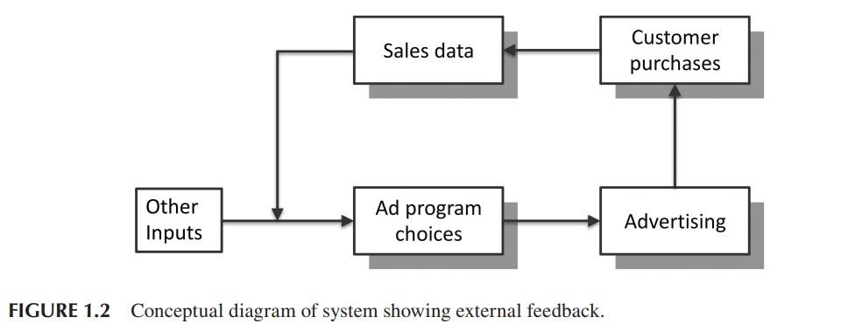

In a well-designed system, each of these activities is performed by a device or person chosen for that purpose. Choosing them is an important part of system design.

**We can visualize the components of an information system as in Figure 1.4. In this diagram:**

*• The elements in the lower half exist physically. We can point to a person or to a computer, and say “That part of the system carries out Activity X.”*

*• The elements in the upper half tell the lower elements on each side what to do. Those two elements must be designed to work with each other.*

*• The element in the middle, data, holds the system together. The physical elements of the system access the data. The instructions tell them what to do with it.*

**1.3 What *is* Information, Really?**

* Some people discuss ***wisdom*** above those three levels, but that’s seldom necessary in discussing information systems.
* ***Knowledge*** is the ability to apply information in a business situation.
* ***Information*** is data that has been organized and processed to be meaningful to a person (or other information system) who (or which) will use it.
* ***Data*** is* raw facts in isolation from other facts.

**Basic Concepts of Information Systems:**

* 1. **Data Input:**
     + *Data starts the information system process.*
     + *It comes from a source and is entered into the system.*

* 1. **Data Processing:**
     + *Data is turned into information through computation and comparison.*
     + *Computation uses predefined processes on data items. For example, calculating movie start time considering travel time.*
     + *Comparison selects steps based on data, helping in decision-making (e.g., choosing when to eat based on movie and dining hall times).*

* 1. **Comparison Usage:**
     + *Helps in selecting output (like students with low grades).*
     + *Organizes data (e.g., sorting alphabetically).*
     + *Formats text and controls computer functions (e.g., mouse pointer interactions).*

**Information Quality: Core Concepts**

* 1. **Correctness:**
     + *Information is correct if derived from accurate data through proper processing.*
     + *Errors can occur due to human mistakes but can be reduced through data automation and validation.*
     + *Approximate values are acceptable for many numerical data, considering practicality.*
  2. **Accuracy:**
     + *Information is accurate if it closely aligns with ideal values.*
     + *Acceptable accuracy depends on the specific use of the information.*
     + *Sensitivity analysis helps assess the impact of inaccuracies on decisions.*
  3. **Precision:**
     + *Precision refers to the smallest difference representable in stored or presented numeric data.*
     + *Precision should match the required accuracy; excess precision can mislead.*
     + *Providing more precision than justified by accuracy can be unethical and misleading.*
  4. **Consistency:**
     + *Consistency ensures that all data contributing to an information item are based on the same assumptions, definitions, and time periods.*
     + *It applies to information or processed data, not individual data elements.*
     + *Inconsistencies can lead to misleading conclusions. For example, comparing last year's sales with the current sales force size without considering growth can distort productivity calculations.*
     + *Globalization introduces challenges, as terms and definitions can vary across countries due to cultural, legal, or regulatory differences, leading to inconsistent data interpretations.*

*\** ***Importance of Awareness****:*

* 1. *Individuals working with information systems need to be aware of consistency issues.*
  2. *Lack of awareness can lead to misinterpretation and errors in decision-making.*
  3. *Information literacy is essential to prevent inconsistencies and ensure accurate analysis and planning in a global context.*

* 1. **Conformity to Needs and Expectations:**
     + *Information must conform to the needs and expectations of whoever will use it.*
  2. **Completeness:**
     + *Information is complete when it is based on all the relevant factors, omitting none.*
  3. **Cost:**
     + *Cost is a measure of the resources an organization uses, expressed in financial terms. Information has a cost.*
     + Importance of Cost Analysis:
       - *Information system justification requires comparing costs and benefits.*
       - *Costs are easily estimated, but assessing benefits, although challenging, is essential.*
     + Value vs. Cost of Information Quality:
       - *Balancing the value of information quality against its cost is crucial.*
       - *Source data automation, enhancing accuracy, must be evaluated based on cost-benefit analysis.*
     + Increasing Investments in Information Quality:
       - *Businesses invest more in information quality due to the growing need for accurate, timely data.*
       - *The cost of obtaining high-quality information decreases annually, making it more accessible.*
     + Cost Trade-offs in Information System Development:
       - *Planning and developing information systems involve strategic cost trade-offs.*
       - *Businesses may choose higher initial costs to reduce long-term operating expenses.*
       - *Opting for more expensive software with lower incremental costs per user is a common consideration.*

**1.4 Legal and Ethical Information Use:**

* **Ethical and Legal Responsibilities:**
  + Using information systems for illegal or unethical purposes is punishable.
  + Individuals with access to information and systems must not misuse them.
  + Unethical use includes information discrimination and unauthorized access.
* **Value of Information and Its Quality:**
  + Information's worth depends on its quality.
  + Information quality involves factors like correctness, accuracy, and consistency.
  + Businesspersons must be vigilant in evaluating, maximizing, and designing information systems to ensure quality.
* **Computers and Intelligent Information Use:**
  + Computer-based systems are essential for intelligent information use in businesses.
  + Businesses must use computer-based systems intelligently for optimal outcomes.
* **Personal and Career Benefits:**
  + Understanding information systems is valuable for career growth.
  + Intelligent use of information systems adds value to employers, leading to promotions and career advancement.